Activity #4 Learning From the Best

In the first three activities, we learned that the job of the cinematographer is to capture on film the images that tell the story. We learned a little about camera techniques, the use of lighting and framing a scene. Now it’s time to look at this year’s nominees. They will be announced in February in 2004. List the nominees for best cinematography in the space below:  Pick one film that you would like to see from the list of nominees. As you watch the film, consider some of the guidelines that members of the Academy follow when making their award selections: |  | 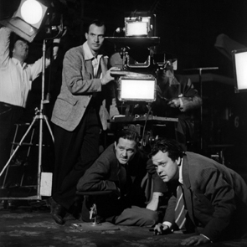  Orson Welles directing
 | - How well did the cinematographer succeed at capturing just the right images to enhance the story?  - How does the mood of the cinematography help to tell the story?  - How does the lighting help to create that mood?  - Does the composition of the shots reflect  an aesthetic sense? Are the camera  moves well-conceived and unobtrusive?  - Do they contribute to the story-telling, adding surprise, impact and emotional  value where needed? | Now put yourself in the shoes of an Academy member. Using what you know about each of the nominated films – either from seeing them or reading about them – predict how the professional filmmakers in the Academy will vote. Then, watch the Academy Awards in March, or read the paper the following day to see how you did with your predictions. Alternatively, view some films honored in the past for achievement in cinematography and describe on the other side of this sheet why you think they won in that category.
After viewing the film, describe why you think the nomination was or was not appropriate. (Keep in mind that beautiful scenery and elaborate settings should not be factors in your evaluation.) |  | For more information about the Academy of Motion Pictures Arts and Sciences, visit these web sites:
- http://www.cinematographer.com
(American Society of Cinematographers)

- http://oscars.com

- http://oscars.org

